(Approx. 1089 words)

Safeguarding Windows 10
By Dick Maybach, Member, Brookdale Computer Users’ Group, NJ
May 2016 issue, BUG Bytes
www.bcug.com
n2nd (at) att.net

If you've taken advantage of the free upgrade to Windows 10 from Windows 7, 8, or 8.1, you're vulnerable to losing it as well as your data if you don't make some preparations. Your old system installation disk or the recovery CD and backups you created will allow you to restore only your old Windows system. If you have a serious crash after July 29, 2016, when the free upgrade period expires, you would then either have to live with your old version or purchase a retail copy of Windows 10. Fortunately, Windows 10 includes utilities to avoid this, but only if you know about and use them, and they are buried deep enough in menus that a casual Windows user may not find them.

Your first task is to create a Windows Recovery Environment on an 8-Gbyte (or larger) USB memory stick with the following procedure.
- Tap the Windows key, type "recovery", and select "Create a recovery drive".
- Select "create recovery drive".
- Be sure the box "Backup systems files to the recovery drive" is selected (Screen 1).
- Click "continue". This is a slow process; don't get impatient.

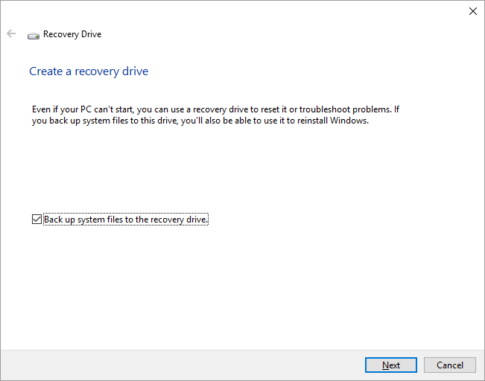
Screen 1. Create a Recovery Drive

This plus a system image (see below) substitute for an installation disk, and they will let you repair Windows and restore your software and data from your backups. Label the memory stick clearly, but before you store it in a safe place, be sure your PC can boot from it. You can also create a recovery environment on a separate hard disk partition, but this less safe as a hard disk failure will destroy it.

You may prefer to create a system repair CD (or make one in addition to a Recovery Environment), a legacy feature from Windows 7 that has fewer features but still allows you to recover your system after serious trouble. Follow these steps to create the disk.
- Tap the Windows key and type “control”.
- Select “Backup and Restore (Windows 7)”.
- Select “Create a system repair disc” (Screen 2, you may be asked for a password) and follow the instructions.

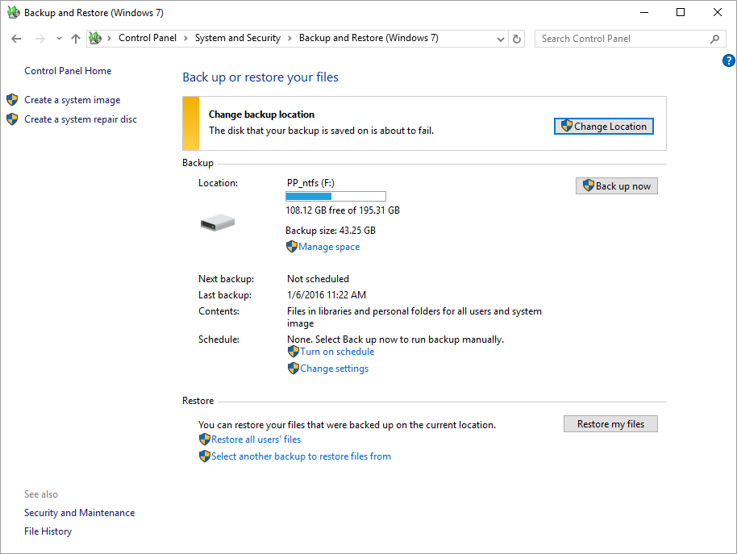
Screen 2. Backup and Restore (Windows 7).

When you boot using a recovery drive memory stick you are in the Windows Recovery Environment, where you can perform the following tasks:
- perform a system reset,
- use a saved system image to overwrite you entire disk,
- repair the startup files,
- enable safe mode, and
- troubleshoot your PC (although this requires some expertise).

Although a Recovery Environment memory stick is essential, by itself it won't let you restore Windows 10. For that, you also need a system image, which is a copy of all the software and data on your hard disk. Portable USB-3, 2-Tbyte drives are now available for less than $100, and these are adequate for most of us. You might prefer an internal drive, especially if you need more capacity, but an external unit does provide the extra protection of being completely separate from your PC.

To create a system image follow this procedure.
- Tap the Windows key, type "control", select "Control Panel" and under "System and Security, select "Save backup copies of your files with File History".
- Select "System Image Backup" (at the bottom left; see Screen 3; you may have to enter your password).
- Select "Create a system image".
- Select "On a hard disk". There are options to use a network drive or DVDs, but the limited capacities of the latter make the procedure tedious indeed (Screen 4).

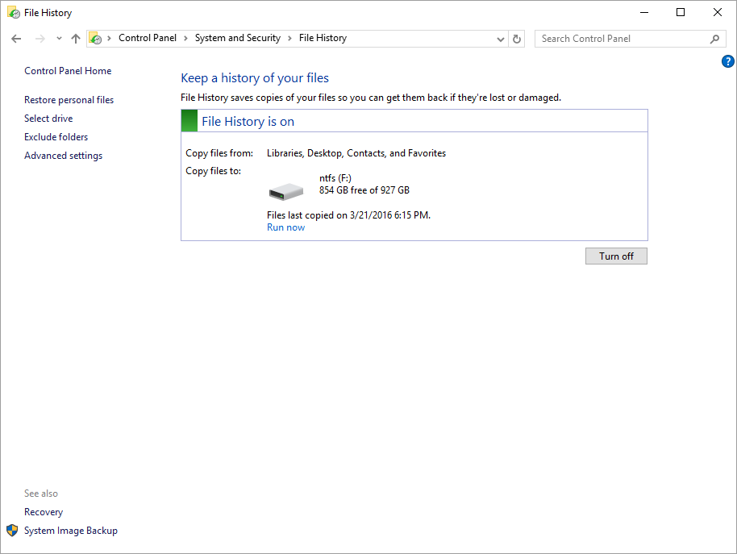
Screen 3. File History.

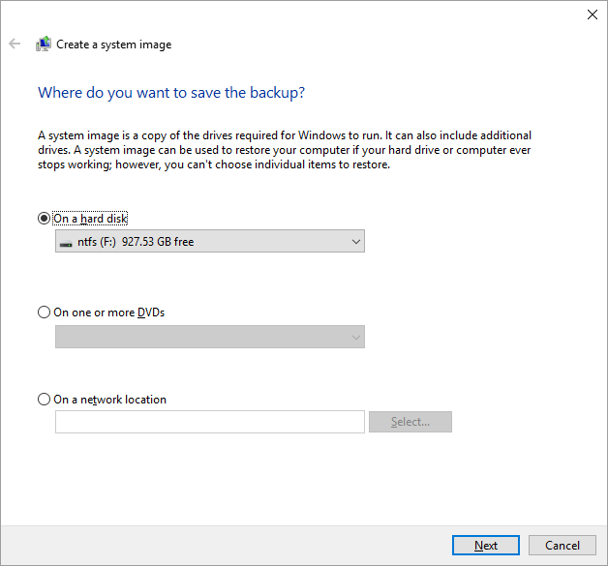
Screen 4. Create a System Image.

Because creating a system image is time-consuming, and restoring one replaces the entire contents of your hard disk with the image, you will probably do this infrequently. The Windows 10 backup is called “file history”, and by default it runs every hour while your backup drive is connected. It's important to remember that file history saves only your data; you must use a system image to restore software. As a result, you will want to store a system image every month or so (depending on how often you install or update your software), although you probably want to save file history much more frequently.

Use this procedure.
- Tap the Windows key, type "settings", select "Settings", then select "Update & security" (Screen 5).
- Select "Backup" (Screen 6).
- If your backup disk is not always connected, select "More options", then select "Back up now" (Screen 7).

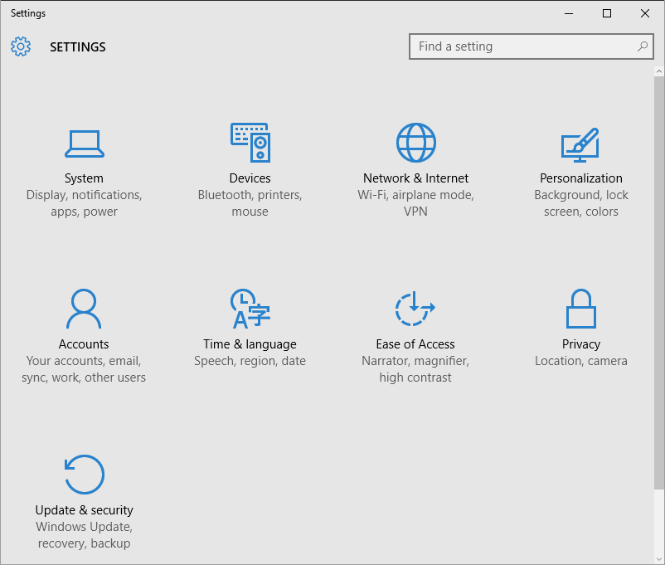
Screen 5. Settings.

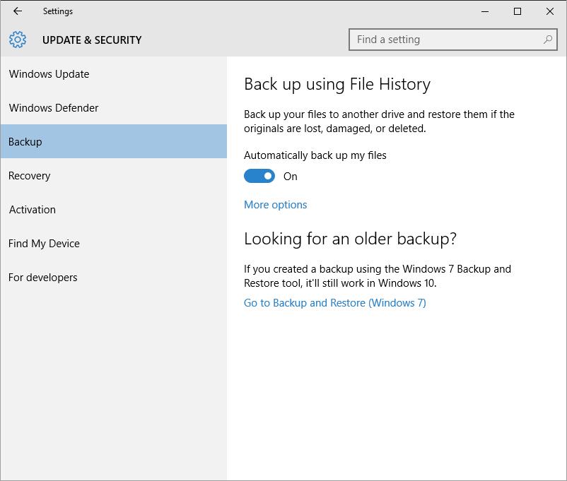
Screen 6. Update & Security.

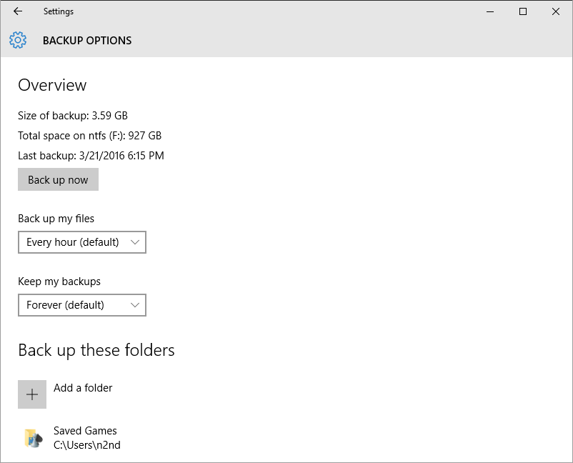
Screen 7. Backup.

The first time through this you have to specify where the histories will be stored. After that, you can just connect the backup drive and Windows will automatically perform the action. You will have to select “Back up now” only if the drive is connected for just a short time. Note on Screen 6 the item “Go to Backup and Restore (Windows 7), which you can use if you prefer it to file history.

Do the following to restore a file from your file history. (If your history is stored on a removable drive, be sure it's connected).
- Tap the Windows key and type “control”.
- Select “Control Panel”.
- Select “Save backup copies of your files with File History” (under System and Security).
- Select “Restore personal files” (see Screen 3 above).

You'll see the following (Screen 8).

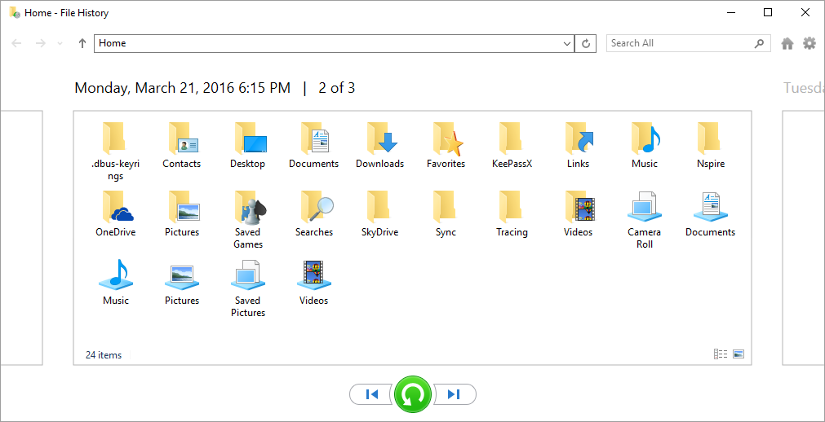
Screen 8. Restore Personal Files.

The files and folders shown are for the date shown. To see earlier version click on the arrow to the left of the green button; to see later ones click on the right arrow. Selecting an item and clicking on the green button will restore it.

However, there is a quicker way to access file history. When you are using the file browser, expand the ribbon (if it's been minimized) by clicking the small down-arrow just to the left of the help button (a blue circle with a question mark). Screen 9 shows a file browser window with an expanded ribbon. Then click on “History” to see the file history screen for an item you've selected.
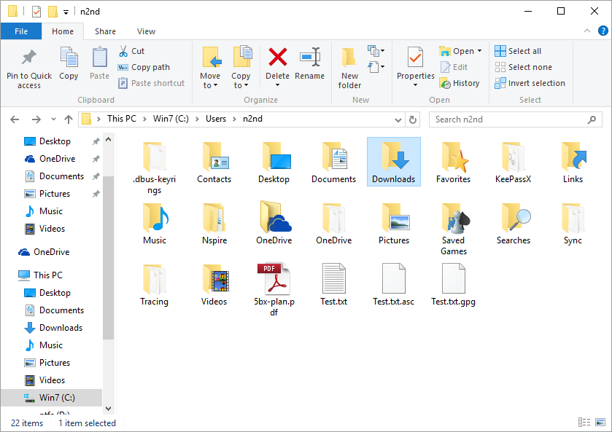
Screen 9. File Browser with an Expanded Ribbon.

As you can see, using file history can be much more convenient than the older backup and restore technique, especially if you keep your history disk connected to your PC. The particular scheme with which you back up your files isn't important, as long as it's effective, but be sure you have one and test it to be sure it works.

